Project Report

Deep Learning Fundus Image Analysis For Early Detection Of Diabetic Retinopathy

Submitted By

Ms.D.Pradhiba

Assistant Professor

Department of Computer science and Engineering,

Kamarak College of Engineering and Technology, Virdhunagar

Mail id:Pradhibacse@kamarajengg.edu.in

Phone No:7418654929

CHAPTER 1

1. Introduction:
Artificial Intelligence (AI) and Machine Learning (ML) are transformative technologies that have gained significant prominence in recent years. These technologies empower machines to learn from data, recognize patterns, and make intelligent decisions without explicit programming. Leveraging the capabilities of AI and ML in conjunction with cloud computing has become a powerful approach to address complex computational tasks and enhance scalability.
1.1 Overview:
AI and ML:
AI: Artificial Intelligence refers to the development of computer systems that can perform tasks that typically require human intelligence. This includes tasks such as problem-solving, understanding natural language, and recognizing patterns.
ML: Machine Learning is a subset of AI that focuses on the development of algorithms and statistical models that enable computers to improve their performance on a specific task through learning from data.
Cloud Computing: Cloud computing involves the delivery of computing services (including storage, processing power, and applications) over the internet, allowing users to access and use these resources on-demand without the need for physical infrastructure.
Key Characteristics:
On-Demand Self-Service
Broad Network Access
Resource Pooling
Rapid Elasticity
Measured Service
AI/ML in the Cloud:
Data Storage and Processing: Cloud platforms provide scalable and cost-effective storage solutions, enabling organizations to store and manage vast amounts of data. This is crucial for ML, as large datasets are often required for training models.
Computation Power: ML models, especially deep learning models, demand substantial computational resources. Cloud services offer powerful and scalable computing resources, allowing organizations to train complex models efficiently.
Scalability: Cloud environments enable easy scaling of AI/ML workloads based on demand. Organizations can scale up or down resources dynamically, optimizing costs and performance.
Accessibility: Cloud-based AI/ML services are accessible from anywhere with an internet connection, facilitating collaboration and remote work.
Managed Services: Cloud providers offer managed AI/ML services that abstract the complexities of infrastructure management. This allows organizations to focus on model development and deployment rather than infrastructure maintenance.

CHAPTER 2
Literature review :
This chapter discusses about the various methodologies used to perform the image analysis of early detection of diabetic retinopathy.
  - Residual Neural Networks (ResNet)
ResNet is a type of CNN that introduced residual learning, addressing the challenges of training very deep networks. ResNet architectures have been applied to fundus image analysis to capture intricate features associated with diabetic retinopathy. The core innovation in ResNet is the introduction of residual blocks. A residual block consists of a shortcut connection (also known as a skip or identity connection) that bypasses one or more layers. Instead of learning the direct mapping, ResNet learns the residual mapping— the difference between the input and output. The output of a residual block is the sum of the input and the learned residual.
  - Inception Networks (GoogLeNet)
Inception networks, known for their inception modules, have been utilized in DR detection. These architectures are designed to capture multi-scale features, making them effective in analyzing retinal images with varying lesion sizes. The inception module is the central architectural component of GoogLeNet. Instead of relying on a single receptive field size, inception modules use multiple filter sizes (1x1, 3x3, 5x5) and pooling operations in parallel. This allows the network to capture both fine-grained and coarser features simultaneously, enabling it to learn a diverse set of features at different scales. Inception modules extensively use 1x1 convolutions to reduce the dimensionality of input feature maps before applying larger convolutions. These 1x1 convolutions serve two primary purposes: dimension reduction and introducing non-linearity through activation functions. They also help control the computational cost of the network.
  - Capsule Networks (CapsNets)
CapsNets, an alternative to traditional CNNs, focus on capturing hierarchical relationships between features. They have shown promise in tasks related to understanding spatial hierarchies in medical images, including fundus images for DR detection. The fundamental building blocks in CapsNets are capsules. Unlike neurons in traditional networks, capsules are designed to represent entities in the input data and encode various attributes, such as orientation, scale, and position. Capsules work collaboratively to encapsulate the instantiation parameters of specific entities, providing a more nuanced representation compared to traditional neural network units.

  - Generative Adversarial Networks (GANs):
GANs have been explored for generating synthetic retinal images or augmenting existing datasets. They can contribute to training deep learning models by providing diverse examples of retinal abnormalities. The generator is a neural network responsible for generating new data samples. It takes random noise as input and transforms it into data that ideally should be indistinguishable from real data. The generator's goal is to create data that is realistic enough to deceive the discriminator.
2.5 Proposed System
The flow of the proposed system consists of
- Data Collection
- Image Preprocessing
- Training and Testing
- Model building
- Performance analysis
- Prediction using GUI

CHAPTER 3
3. Theoritcal Analysis
3.1 Block Diagram
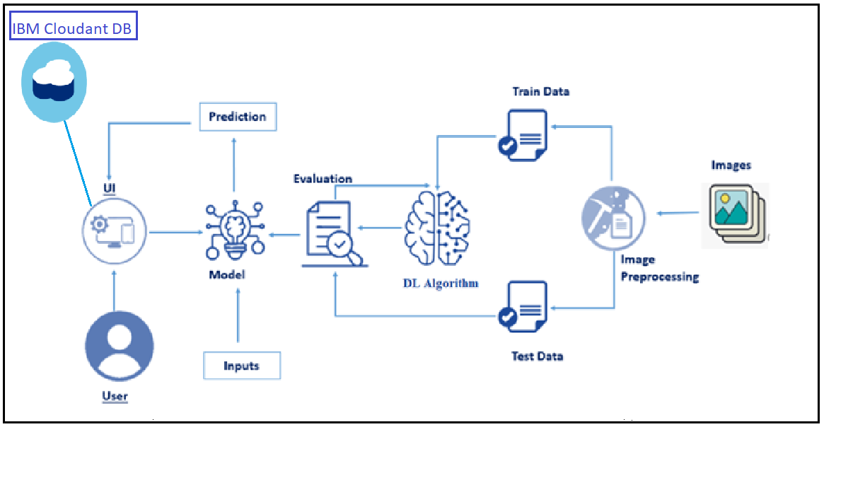
Fig 3.1 proposed system
3.2 Hardware / Software designing
To accomplish this, we have to complete all the activities and tasks listed below
- Data Collection.
  - Create a Train and Test path.
- Data Pre-processing.
- Import the required library
- Configure ImageDataGenerator class
- ApplyImageDataGenerator functionality to Trainset and Testset
- Model Building
  - Pre-trained CNN model as a Feature Extractor
  - Adding Dense Layer
  - Configure the Learning Process
  - Train the model
  - Save the Model
  - Test the model
- Cloudant DB
  - Register & Login to IBM Cloud
  - Create Service Instance
  - Creating Service Credentials
  - Launch Cloudant DB
  - Create Database

- Application Building
  - Create an HTML file
  - Build Python Code

CHAPTER 4

4.1 Experimental Investigation:
Strucure of implementation
The proposed methodlogy implemented based on the following flow,
- Download the dataset
- Model Building
- Cloudant DB
- Application Building
Dataset downloaded from Kaggle, and images are preprocessed, testing and training images are separated. Model built using Xception and Softmax. CloudantDB created then Python Flask application used to build web application.
4.2 Dataset
To build a DL model we have to split training and testing data into two separate folders. But In the project dataset folder training and testing folders are presented. So, in this case we just have to assign a variable and pass the folder path to it.Four different transfer learning models are used in our project and the best model (Xception) is selected.The image input size of xception model is 299, 299.
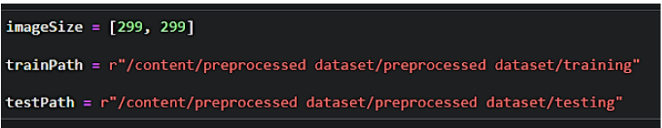
Import the necessary libraries as shown in the image.
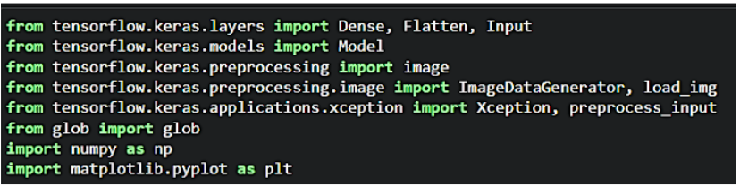
ImageDataGenerator class is instantiated and the configuration for the types of data augmentation
CHAPTER 6

6.1 RESULTS
- FLASK Application Index.html
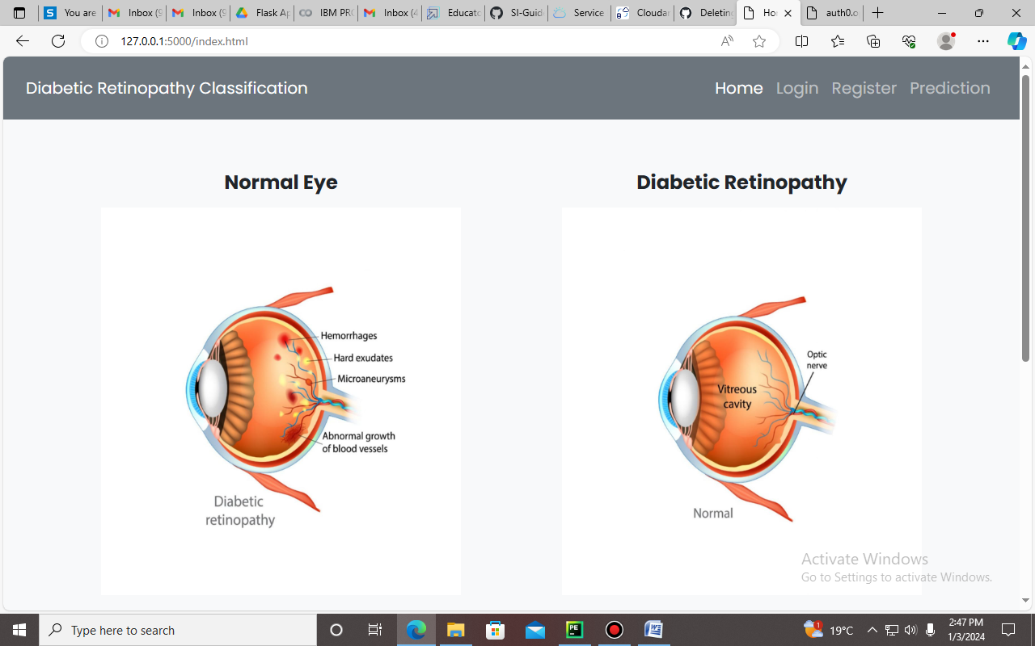

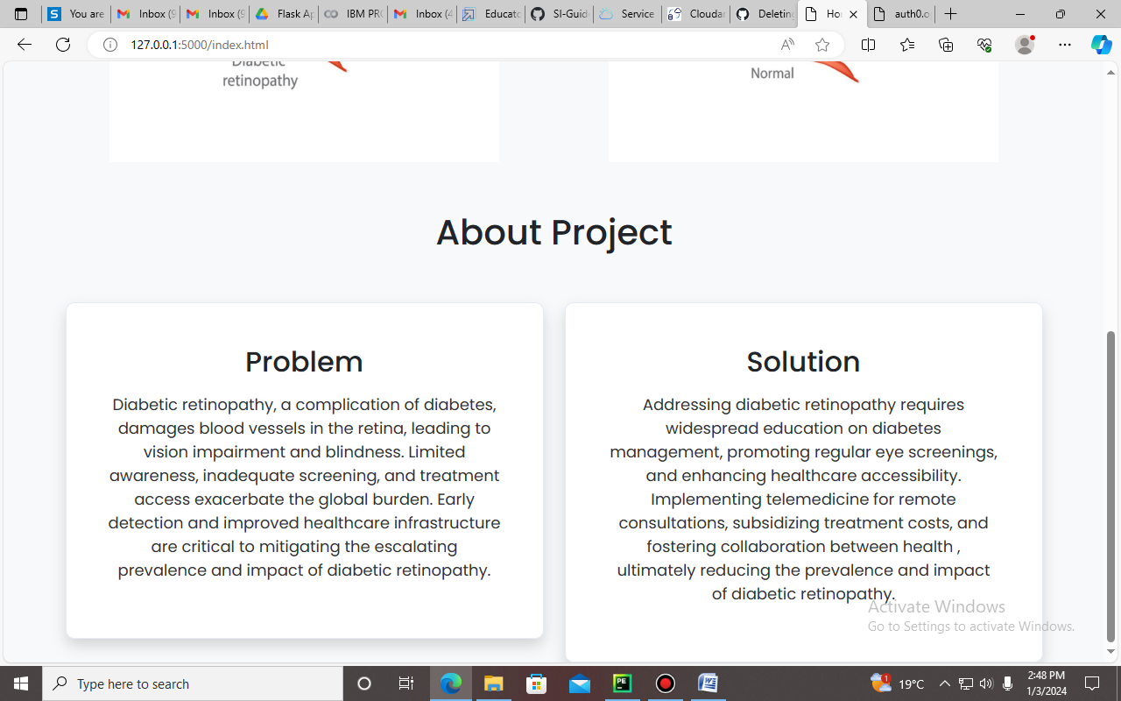

- Register.html
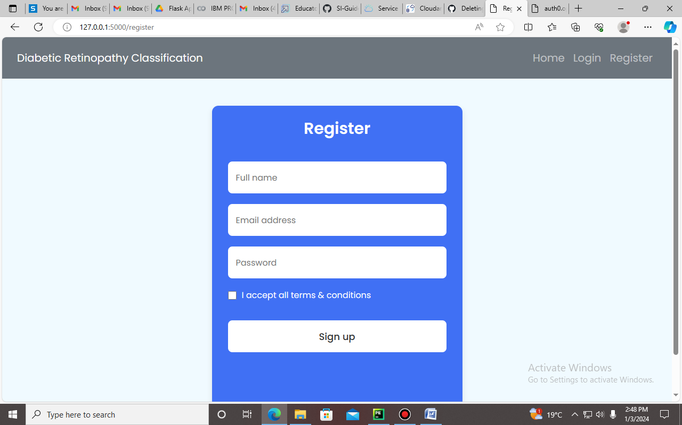

- Login.html
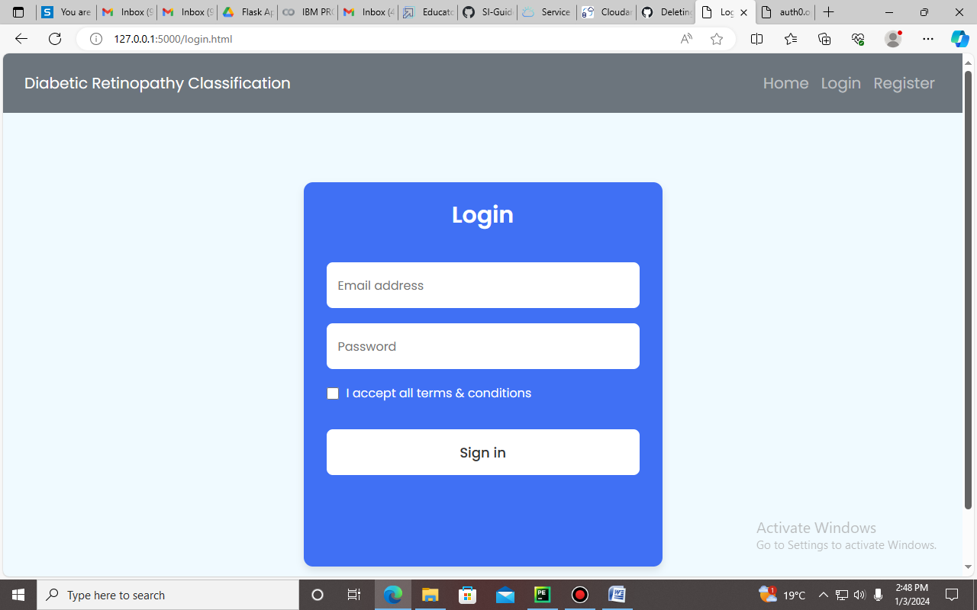

- Classification.html
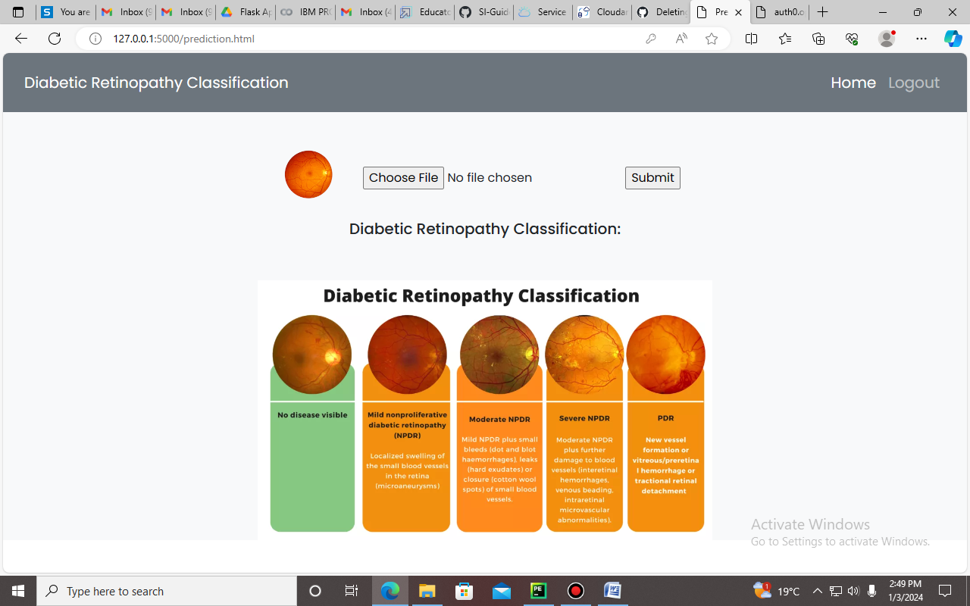

- Prediction

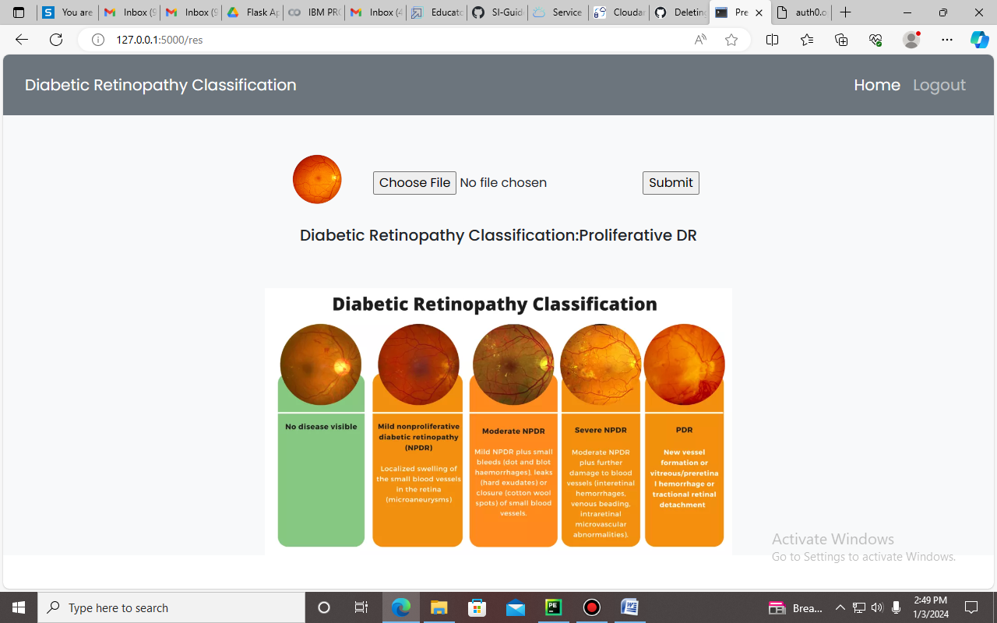
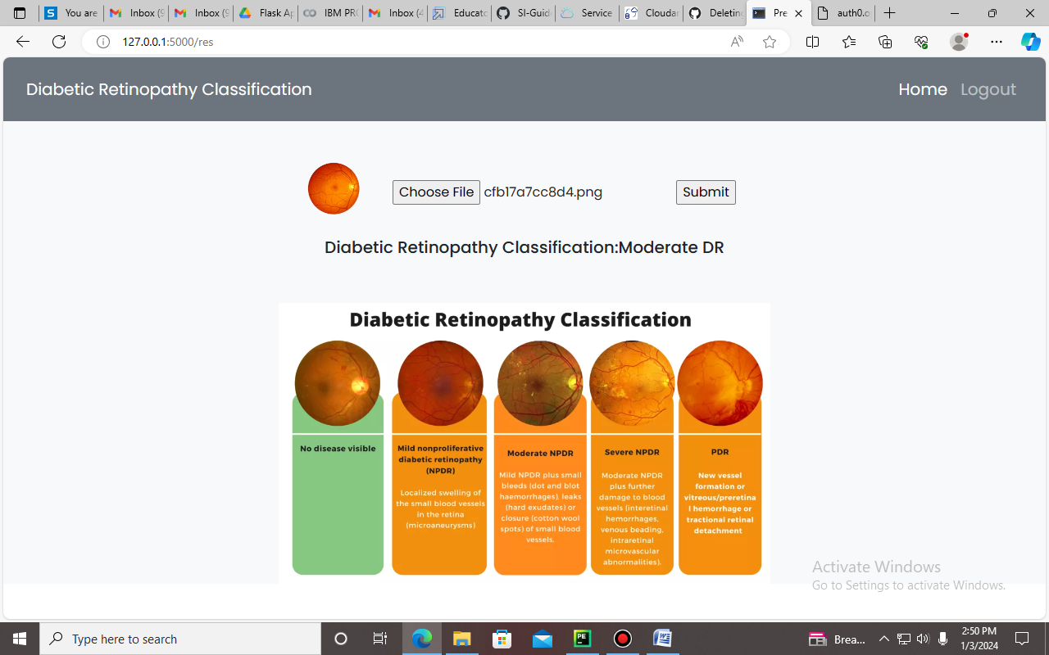

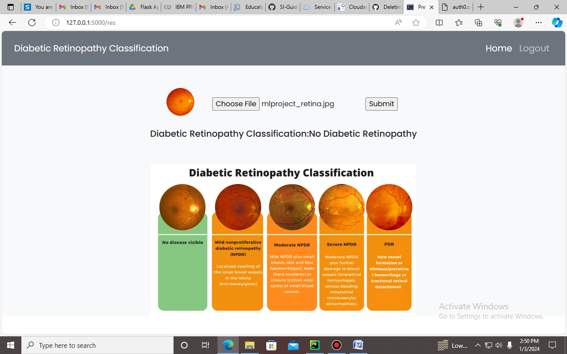

- Cloudant – Database connection
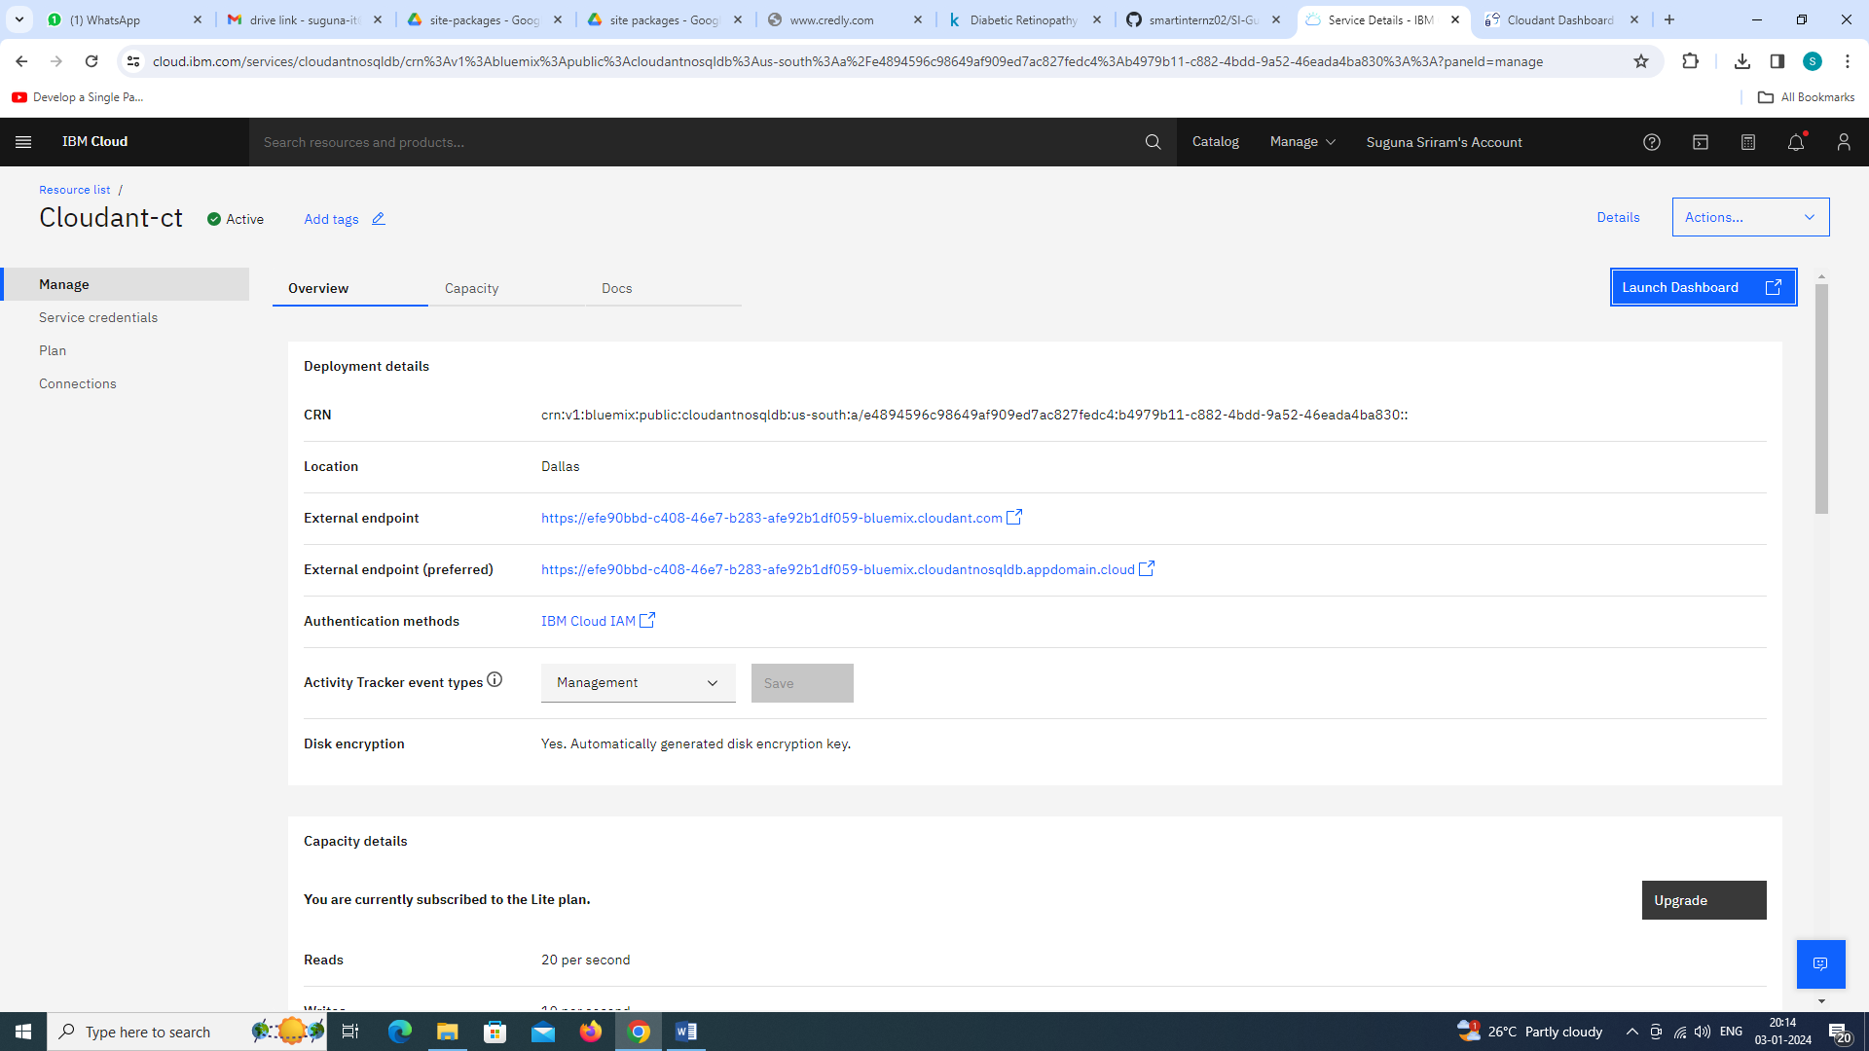
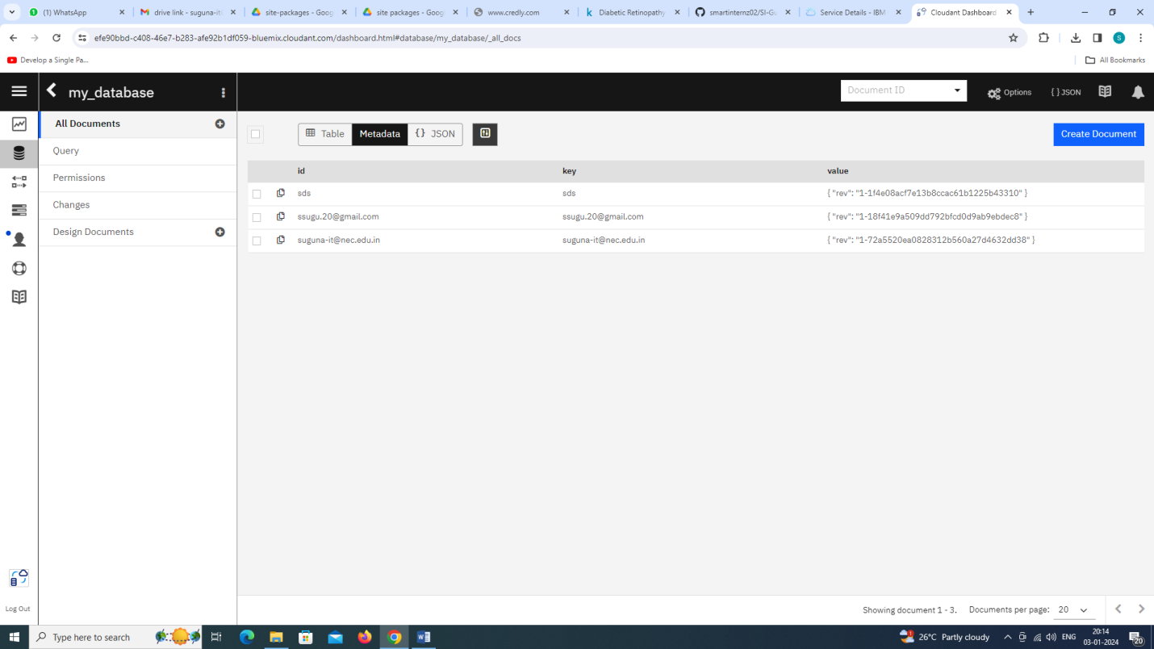

CHAPTER 7

7. ADVANTAGES & DISADVANTAGES
7.1 Advantages
Scalability: Cloud computing provides on-demand resources that can scale horizontally to handle varying workloads, making it well-suited for the resource-intensive nature of AI/ML tasks.
Cost-Efficiency: Pay-as-you-go models in cloud computing allow organizations to optimize costs by paying only for the resources consumed, reducing upfront capital investments.
Accessibility: Cloud-based AI/ML services can be accessed from anywhere with an internet connection, facilitating collaboration and enabling remote teams to work on shared projects.
Global Reach: Cloud providers have data centers distributed globally, allowing organizations to deploy AI/ML applications closer to end-users, reducing latency and improving user experience.
Managed Services: Cloud platforms offer managed AI/ML services that abstract the complexities of infrastructure management, enabling organizations to focus on model development and deployment rather than infrastructure maintenance.
Innovation Acceleration: Cloud computing environments provide a flexible and agile infrastructure, allowing organizations to experiment, innovate, and rapidly prototype new AI/ML models without significant upfront investments.
Collaboration: Cloud-based platforms facilitate collaborative development by providing centralized environments for model development, testing, and deployment, fostering teamwork among data scientists and engineers.
Security Measures:Leading cloud providers invest heavily in security measures, including data encryption, access controls, and compliance certifications, ensuring a secure environment for AI/ML applications.
7.2 Disadvantages
Data Privacy Concerns: Storing sensitive data in the cloud raises concerns about data privacy and security, especially when dealing with regulatory compliance and industry-specific requirements.
Latency Issues:The reliance on cloud infrastructure may introduce latency, which can be a critical factor for real-time AI/ML applications, such as those deployed in edge computing scenarios.
Dependency on Internet Connectivity:Cloud-based solutions require a reliable internet connection. In situations where connectivity is unstable or unavailable, access to AI/ML services may be disrupted.
Cost Variability: While cloud computing can be cost-efficient, costs can become unpredictable as workloads fluctuate, and data storage requirements increase, potentially leading to unexpected expenses.
Limited Control Over Infrastructure:Organizations have limited control over the underlying infrastructure in cloud environments. This lack of control may be a concern for those who require fine-tuned optimization for specific hardware configurations.
Vendor Lock-in: Adopting specific cloud services may lead to vendor lock-in, making it challenging to switch providers due to dependencies on proprietary APIs and services.
Security Risks:While cloud providers implement robust security measures, the shared nature of cloud environments introduces potential security risks, such as unauthorized access and data breaches.
Regulatory Compliance Challenges:Compliance with data protection regulations and industry-specific standards may pose challenges, particularly when data is stored or processed across different geographical regions.
Learning Curve: Transitioning to cloud-based AI/ML solutions may require organizations to invest in training and upskilling their workforce to adapt to new tools and platforms.
Environmental Impact:The energy consumption of large-scale cloud data centers can contribute to environmental concerns. Balancing the growing demand for AI/ML services with sustainable computing practices is a challenge.

CHAPTER 8

8. APPLICATIONS
Healthcare:
Diagnostic Imaging: AI algorithms, hosted on cloud platforms, analyze medical images such as X-rays, MRIs, and CT scans for the early detection of diseases.
Drug Discovery: Cloud-based AI accelerates drug discovery processes by analyzing vast datasets, predicting potential drug candidates, and optimizing molecular structures.
Finance:
Fraud Detection: AI algorithms running on the cloud analyze transaction patterns in real-time, identifying and preventing fraudulent activities in banking and financial transactions.
Algorithmic Trading: Cloud-based AI systems use machine learning to analyze market trends, execute trades, and optimize investment portfolios.
Retail:
Demand Forecasting: AI models in the cloud analyze historical sales data and external factors to predict future demand, optimizing inventory management for retailers.
Personalized Marketing: Cloud-based AI systems analyze customer data to provide personalized recommendations, improving the effectiveness of marketing campaigns.
Manufacturing:
Predictive Maintenance: AI algorithms on the cloud analyze sensor data from equipment to predict maintenance needs, reducing downtime and optimizing machinery performance.
Quality Control: Cloud-based AI systems inspect and analyze production lines, identifying defects and ensuring product quality.
Telecommunications:
Network Optimization: AI in the cloud optimizes network performance by analyzing data traffic patterns, predicting network failures, and dynamically adjusting resources.
Customer Service: Cloud-based AI-powered chatbots provide customer support, handling queries, and resolving issues through natural language processing.
Education:
Personalized Learning: Cloud-based AI platforms analyze students' learning patterns, providing personalized educational content and adapting to individual learning styles.
Automated Grading: AI algorithms in the cloud automate the grading process, providing timely feedback to students and reducing the burden on educators.
Smart Cities:
Traffic Management: Cloud-based AI systems analyze real-time traffic data to optimize traffic flow, reduce congestion, and improve overall transportation efficiency.
Public Safety: AI applications in the cloud enhance public safety by analyzing data from surveillance cameras, detecting anomalies, and alerting authorities to potential security threats.
Energy:
Grid Management: Cloud-based AI systems optimize energy distribution by analyzing consumption patterns, predicting demand, and balancing energy grids.
Energy Efficiency: AI algorithms on the cloud analyze data from sensors to optimize energy usage in buildings and industrial facilities, reducing overall energy consumption.
Human Resources:
Talent Acquisition: Cloud-based AI platforms assist in screening resumes, identifying suitable candidates, and streamlining the recruitment process.
Employee Engagement: AI-driven tools in the cloud analyze employee data to improve engagement, identify retention risks, and enhance workplace satisfaction.
Agriculture:
Precision Farming: Cloud-based AI applications analyze data from sensors, satellites, and drones to optimize farming practices, including irrigation, fertilization, and pest control.
Crop Monitoring: AI models on the cloud analyze imagery to detect crop diseases, monitor plant health, and provide insights for yield optimization.
CHAPTER 9

9.1. CONCLUSION
In conclusion, the integration of Artificial Intelligence (AI) and Machine Learning (ML) with cloud computing is a transformative force shaping modern technology. This symbiotic relationship leverages scalable computing resources, advanced data analytics, and intelligent decision-making capabilities. The synergy between AI/ML and cloud computing spans diverse industries, including healthcare, finance, manufacturing, and agriculture. The advantages include scalability, cost-efficiency, accessibility, and global reach, enabling organizations to innovate without substantial upfront investments. Managed services simplify AI/ML development, allowing a focus on problem-solving rather than infrastructure management. However, challenges like data privacy concerns and potential vendor lock-in must be carefully navigated. Addressing environmental impacts and promoting sustainable computing practices are evolving considerations. Proposed systems, such as enhanced AutoML with federated learning and serverless AI/ML deployment frameworks, demonstrate ongoing efforts to refine and advance this integration. These innovations aim to overcome limitations and contribute to the evolution of AI/ML and cloud computing technologies. In summary, this integration continues to drive efficiency, informed decision-making, and new possibilities across science, business, and society.

CHAPTER 10

10.1. FUTURE SCOPE
The future scope of integrating Artificial Intelligence (AI) and Machine Learning (ML) with cloud computing is exceptionally promising, with numerous opportunities for advancements and innovations. Here are key areas of future scope:
Advanced AI Algorithms:
The development of more sophisticated AI algorithms, including deep learning models, will continue. Enhanced algorithms will lead to better accuracy, faster processing, and improved decision-making capabilities.
Edge Computing Integration:
The integration of AI/ML with edge computing is expected to grow. This approach will enable real-time processing of data closer to the source, reducing latency and enhancing the performance of applications in fields like healthcare, manufacturing, and IoT.
Explainable AI (XAI):
Future AI systems will likely prioritize explainability, making it easier for users to understand and trust the decisions made by AI models. Explainable AI is crucial, especially in sensitive domains such as healthcare and finance.
Quantum Computing and AI:
The intersection of quantum computing and AI holds significant potential. Quantum computing may revolutionize the processing power available for complex AI tasks, opening new frontiers in machine learning capabilities.
AutoML Advancements:
AutoML tools are likely to become more sophisticated, automating not only model selection and hyperparameter tuning but also addressing feature engineering and data preprocessing, making AI more accessible to non-experts.

CHAPTER 11
REFERENCES

- Gulshan, V., Peng, L., Coram, M., Stumpe, M. C., Wu, D., Narayanaswamy, A., ... & Webster, D. R. (2016). Development and validation of a deep learning algorithm for detection of diabetic retinopathy in retinal fundus photographs. JAMA, 316(22), 2402-2410.
- Abràmoff, M. D., Lou, Y., Erginay, A., Clarida, W., Amelon, R., Folk, J. C., ... & Niemeijer, M. (2016). Improved automated detection of diabetic retinopathy on a publicly available dataset through integration of deep learning. Investigative ophthalmology & visual science, 57(13), 5200-5206
- Ting, D. S. W., Cheung, C. Y. L., Lim, G., Tan, G. S. W., Quang, N. D., Gan, A., ... & Wong, T. Y. (2017). Development and validation of a deep learning system for diabetic retinopathy and related eye diseases using retinal images from multiethnic populations with diabetes. JAMA, 318(22), 2211-2223
- Gargeya, R., & Leng, T. (2017). Automated identification of diabetic retinopathy using deep learning. Ophthalmology, 124(7), 962-969
- Li, Z., Keel, S., Liu, C., He, Y., Meng, W., & Scheetz, J. (2017). An automated grading system for detection of vision-threatening referable diabetic retinopathy on the basis of color fundus photographs. Diabetes care, 40(3), 365-371

